8.0 Enclosure

**8.1 Enclosure Design Software**

The MAIDS’ enclosure was designed using CorelDraw 2018 for precise laser cutting running under the Windows 10 operating system. CorelDraw 2018 can export either .svg or .pdf files which are the preferred files for laser cutting.

**8.2 Enclosure Design Software**

The MAIDS’ design document size was restricted to be within the maximum laser table size of 12″ high by 24″ wide. The document was oriented in landscape and ensuring that any artwork is constrained within the 12″x 24″ document size.

**8.3 Enclosure Design Stroke Width and Line Colors**

The laser cutter uses vector lines to cut with the Stroke Width set to Hairline (0.000 mm wide). Outside laser cuts are colored green while inside cuts are colored red. Etching of words or logos requires any other color and lines thicker than 0.000 mm (hairline) which will result in the burning a light layer off of the top of the material.

**8.4 Enclosure Design and Materials**

The enclosure for the MAIDS project used 3 mm thick white acrylic sheet as its base material. The design incorporated a small footprint, hollow-shell, 10 layer-stacked model designed for easy assembly and in order to reduce desktop footprint, provide boards protection as well as weight reduction.

**8.5 Enclosure Design Heat Dissipation Consideration**

Design of the MAIDS’ enclosure implements heat dissipation measures. The case includes the following heat dissipation components:

1. Four aluminum heat sinks (CPU, memory, Ethernet and USB). The properties that make aluminum heatsinks appropriate for the MAIDS project are: Good thermal and electrical conductivity, Low density with a density ~ 2,700 kg/m3, Low weight, High strength of between 70 and 700 MPa, Easy malleability, Excellent corrosion resistance, non-magnetic which avoids interference of magnetic fields and Easy to recycle. (Radian, 2020)
2. A 30 mm x 30 mm fan for heat dissipation (connected to 3.3 V DC and GND GPIO pins on board).

**8.6 Enclosure Design Physical Characteristics**

The MAIDS’ enclosure physical characteristics are as follows:

1. 85 mm (length) x 56 mm (width).
2. Accommodates holes for:
   1. A C-Type power connector
   2. Two micro HDMI connectors
   3. An audio port
   4. Port for USB 3.0
   5. Port for USB 2.0
   6. Port for Ethernet connectors.
   7. Port for a display device
   8. Port for a camera connector.

**8.7 Enclosure Design Etched Icons**

The MAIDS’ enclosure integrates case icons and logo clearly identifying available connectors. The icons and logo are etched onto the outward-facing enclosure surfaces and are as follows:

**Table 7 MAIDS Icons and Logos.**

|  |  |
| --- | --- |
| Icon Description | Icon Image |
| I Love You Son |  |
| HDMI |  |
| USB2 and USB3 |  |
| SD Card |  |
| Sound |  |
| Power Supply |  |
| Internet |  |
| MAIDS Logo | C:\Users\MIDAS2\AppData\Local\Microsoft\Windows\INetCache\Content.MSO\E6EDE8D7.tmp |

**8.8 Enclosure Final Deliverable**

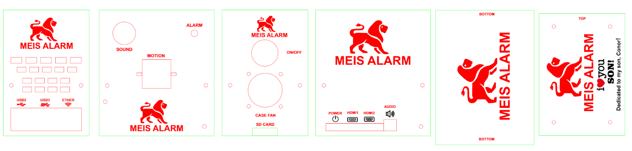

**Figure 12 maids enclosure artwork design.**

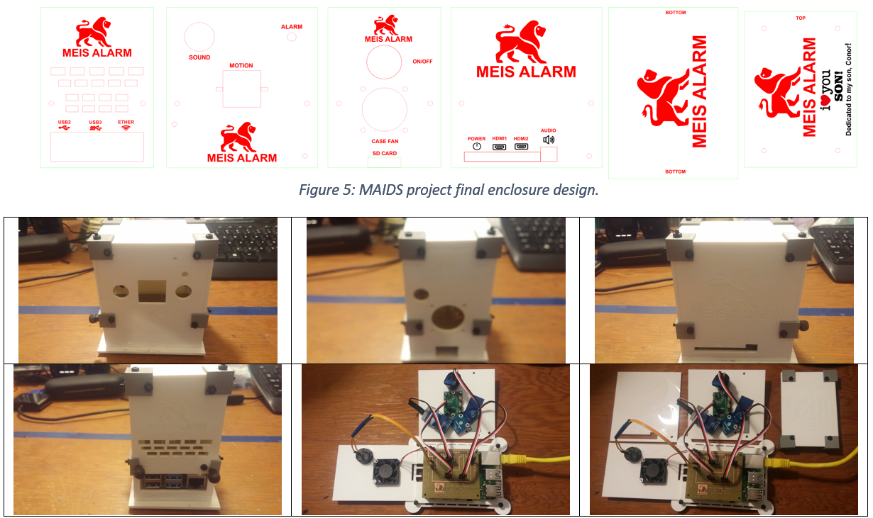

|  |  |
| --- | --- |
|  |  |
|  | C:\Users\MIDAS2\Desktop\HUMBER 2020\20191123_203024.jpg |
| C:\Users\MIDAS2\Desktop\HUMBER 2020\20191123_203002.jpg | C:\Users\MIDAS2\Desktop\HUMBER 2020\20191123_202945.jpg |

**Figure 13 maids final enclosure deliverable.**

**8.9 Enclosure Final Status Report**

Prepared by Claudio F. Meis, February 15, 2020.

The presentation of the MAIDS project at the Capstone Project EXPO at 1:00 – 4:00 p.m. on Thursday, April 9, 2020, is still on track.

The following work has been completed on the MAIDS PCB board:

* Enclosure design.
* Enclosure Specifications.
* Enclosure Fabrication.
* Enclosure Deliverable.

**Progress against Milestones**

Enclosure Design

Milestone 100%

Progress 100%

Enclosure Specifications

Milestone 100%

Progress 100%

Enclosure Fabrication

Milestone 100%

Progress 100%

Enclosure Deliverable

Milestone 100%

Progress 100%

**Key Issues**

No issues need to be resolved to meet Capstone Project EXPO deadline.

**Action Steps**

None.